8.64: a)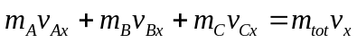, therefore

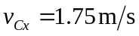

Similarly,

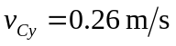

b)
